**STATEMENT OF WORK**

**BOT RPA System Migration**

**(Migration from St.Cath vCenter to Azure AVS vCenter)**

This Statement of Work (“SOW”) is entered into this th day of 2023 (“Effective Date”), by and between THK Rhythm Automotive Michigan Corp, having its principal place of business at 902 Lyons Road, Portland MI 48875 (“TRA”), and Netlink Software Group America Inc., having its principal place of business at 999 Tech Row, Madison Heights, Suite 100, Michigan 48071 (“Netlink”). This SOW is subject to and made an integral part of the Master Services Agreement between TRA and Netlink effective March 01st, 2021 (the “Agreement”). The terms of the Agreement are incorporated herein by this reference. Capitalized terms used by not otherwise defined will have the meaning ascribed to them in the Agreement. In the event that a conflict arises between the terms set forth in the Agreement and those set forth in this Statement of Work, the terms of the Agreement shall control.

1. Background & Justification

THK Rhythm Automotive St.Cath operates RPA BOT system to run their business processes. However, we have noticed that the server "10.160.40.30" and "10.160.34.17" freezes and gets stuck sometime. Also we have noticed that the TRA server goes down frequently and screen resolution of the server 10.160.34.17 keeps changing itself.

* + - * 1. **Pre-requisites:**
* Gather the details of current Firewall rule created for server IP 10.160.34.17 and "10.160.40.30" including user access details.
* Gathering details of the license dependency post migration and DB migration.
* Dependency of current IP address 10.160.34.x and 10.160.40.x with the application/DB and License
* Downtime window of 24 Hrs. to export + Copy to Azure infra and import OVF on AVS

**Current Server configuration**

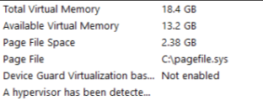

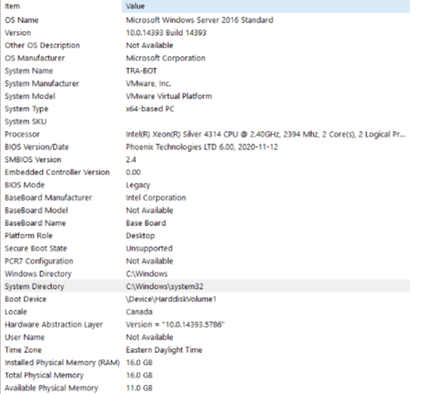

1. Description of Services

The scope of work is as follows:

* Shutdown the production server.
* Export OVF from existing vCenter
* Copy that Exported OVF to Azure environment and import in AVS vCenter.
* Configure new IP address 10.160.57.xx and create new Firewall Rules on Azure Firewall and provide access to the users(Same as existing).

## **2.1** **Compute and Storage**

|  |  |  |  |
| --- | --- | --- | --- |
| Sr.No | Component | Quantity | Duration |
| 1. | Storage | 100 GB | NA |
| 2. | Memory | 16 GB | NA |
| 3. | CPU | 2 CPU Cores | NA |

Apart from above, we need to keep the original server shutdown for 1 Month till all functionality checked and tested.

## **2.2 Licenses**

* Windows
* Application
* Database

1. Fees

| **Services** | **Charge** | **Payment Type** |
| --- | --- | --- |
| RPA server migration | $ XXX,000 | One Time |
| **Total** | **$ XXX,000** | **One Time** |

Payment Schedule

|  |  |
| --- | --- |
| **Month** | **Amount** |
| June 2024 | $ XXX,000 |
| July 2024 | $ XXX,000 |

1. Payment Terms

* Payment terms will be governed as per the signed MSA between Netlink & TRA
* If travel is required, T&A charges will be billed on actual basis as per the TRA’s travel policies. All travel will follow an approval protocol mutually established with TRA.

1. Term

This reinstated SOW term is hereby amended to extend through Midnight Eastern Standard Time on **February 29, 2026** unless terminated earlier by TRA in accordance with the Master Services Agreement dated _______________, 2021.

1. Entire Agreement

This SOW, including all attachments and exhibits, contains the entire agreement between the parties with respect to the subject matter of this SOW (superseding any prior agreement that may otherwise apply), and any statements, representations and/or understandings not set forth herein, including the printed terms of any purchase order, shall be of no force or effect. This SOW may only be amended by a writing that is executed by both parties.

The undersigned individuals who execute this SOW represent and warrant that they have full legal authority to execute this SOW and thereby bind the parties to full performance.

**Agreed and Approved:**

| **TRA** | **Netlink** |
| --- | --- |
| By: | By: |
| Name: | Name: |
| Title: | Title: |
| Date: | Date: |